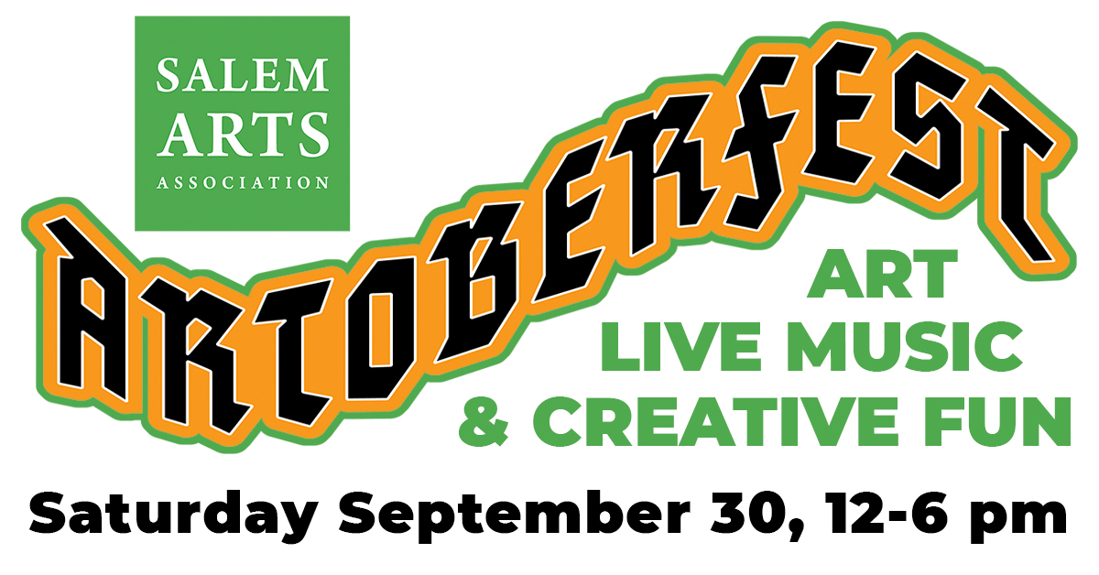
FOR IMMEDIATE RELEASE
September 24, 2023
Contacts: James Bostick or Heather Stewart
Phone: (978) 745-4850
Email: Publicity@SalemArts.org
Web: www.SalemArts.org

Media overview, Images and event graphics
https://salemarts.org/Artoberfest-Media-Info

Salem Arts Association announces our annual Artoberfest Music and Art Festival
Saturday September 30, 2023 - 12 to 6 PM
Salem Arts Association is proud to present Artoberfest 2023.
https://salemarts.org/artoberfest-2023
Join us for our 3rd Annual Artoberfest. It’s Octoberfest with a Creative Twist!
When: Saturday September 30, 12-6 pm
Where: Salem Maritime Historic Site, 160 Derby Street, located on the park next to the Salem Arts Association.

Artoberfest is a FREE event featuring live music, dance, art making, food, & Beer Garden. Bring a blanket, get comfy and enjoy a day of art and live entertainment and Creative Fun on Derby Street in Salem MA.
This year Salem Arts Association once again brings a creative twist to the tradition of celebrating Oktoberfest. With this, our third year presenting Artoberfest, we are setting a new tradition as an annual autumn celebration of arts and music in Salem. The 2021 and 2022 events drew large crowds to the Salem Maritime National Historic Site Park for a full day of music, artist live painting, activities, dance, music, food, beverages, and more. This year we expect to build on last year's successful event. Salem Arts Association sees this celebration as an open call for our local community to kick back and relax with all local performers and vendors to kick off Salem's Haunted Happenings season in creative style.
Music Performances by Lois Lane and the Daily Planets, Jim and Tonic Band, The Derby Girls featuring Amy Gallo (Billings), Christine Baze (Yellow Umbrella) & Erinn "2N" Brown, and Los Sugar Kings.
Art activities including live artists at work including Erin Survillas, Sheila Farren Billings, The October House, Wendy Snow Lang, Charles Lank, Janet Schwartz, and David Kaphammer. Dance performance by Gatto Belly Dance Troupe. Meet Chelsea Page Moses, Miss Trans Massachusetts 2023. Create with our Salem Public Artist in Residence Claudia Paraschiv, for conversation and art-making workshops to create the Tree of Care + Wonder. Play along in the "Instrumental Impact" musical playground tent with Brian Cogger.
Enjoy Pigpen’s Barbecue Pit, The Stand: Fresh Squeezed Lemonade, and local brews from NOTCH Brewing Beer Garden.
Visit our website for schedules and more information about our performers, partners, and sponsors.
https://salemarts.org/artoberfest-2023

Artoberfest Exhibition
The festival is accompanied by a gallery exhibition featuring Salem Arts Association members and community of artists who explore Salem’s history with autumn, Halloween, witchcraft, and the spirit of the season. The resulting exhibit represents diverse interpretations of the theme and how, by bringing them together, we create a collective understanding of these themes.
On display September 16 through Saturday November 22, 2023
Gallery Hours: Saturdays & Sundays from 12-6 pm
159 Derby Street, Salem MA 01970

We couldn’t do this without our amazing sponsors. Please support these local businesses and they are supporting Artoberfest!
Thank you to our Title Sponsors, Peabody Essex Museum, Mercy Tavern, and The Wandering Stage.
Supporters: Sounds of Salem Soul (SOSS Records), Wolf Next Door Coffeeshop, The Lobster Shanty, and All Souls Lounge; along with community support from Salem Access Television and Creative Collective. We also thank the Salem National Historic Site for supporting the arts on our local US National Park Land.
This program is supported in part by a grant from the Salem Cultural Council, Peabody Cultural Council, and Swampscott Cultural Council, local agencies which are supported by the Mass Cultural Council, a state agency.
Artoberfest is supported by tourism dollars through Destination Salem.

Media Contacts:
Jim Bostick, Publicity@SalemArts.org
Heather Stewart, President, Heather@SalemArts.org
(978) 745-4850

About Salem Arts Association.

Salem Arts Association is an entirely volunteer-run nonprofit arts organization that brings art, in all its forms, to the community and brings the community, in all its diversity, to the arts in Salem, Massachusetts. Since incorporating as a non-profit corporation in 2007, Salem Arts Association has produced hundreds of exhibitions, events, and workshops for Salem’s residents and visitors.

Salem Arts Galleries and Shop are located at 159 Derby Street in Salem MA. Regular gallery hours are 12-6 on Saturdays and Sundays.

Visit www.salemarts.org

###

